14 Making Site More Responsive with Media Queries

<https://www.youtube.com/watch?v=_a5j7KoflTs>

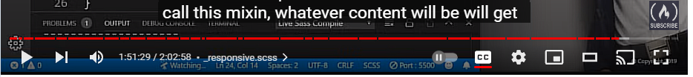

# Turn on Sass

In Visual Studio

Remember to turn on your Watch Sass



# Adding a Mixin

Go to your config.scss partial file



@mixin media-md{

@media screen and (min-width: 768px) {

@content;

}

}

# Copy and Paste 2 more Sizes



Make these changes to the new two media queries

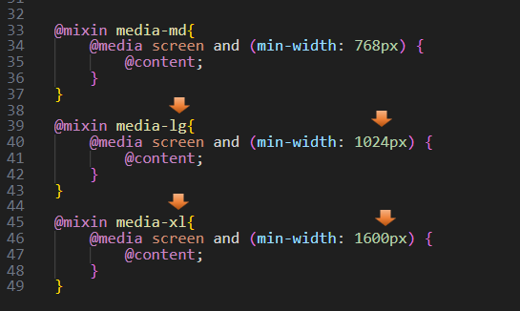

Go back to the Home page



# Start a New Partial responsive.scss File

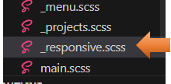

Go to the main.scss file



@include new File in main.scss

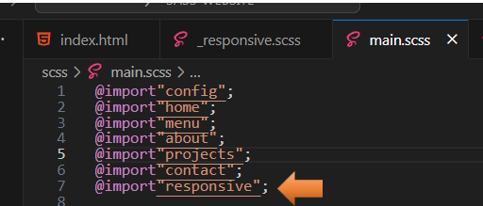

# Home Page responsive design

Go to Your Partial responsive.scss File

We will begin to write our code for the home page.

Start by @including your mixin media queries. Start with the smaller sizes and work our way up

@include media-md {

}

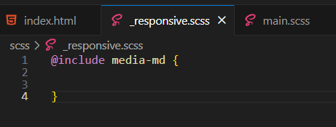

Now start to write your code inside of this media query

@include media-md {

.menu-btn {

visibility: hidden;

}

.nav {

visibility: visible;

.menu-nav {

display: block;

transform: translateY(0);

height: 100%;

background:transparent;

text-align: right;

&__item {

display: inline;

padding-right: 1.5rem;

}

&__link {

font-size: 1.5 rem;

}

}

}

}

# Test the Page

Go to index.html to test the page. You will notice when we hit a wider screen size, the layout will change from viewing the small hamburger menu to a navigational menu across the top of the page.

Smaller device design



Wider device design



# About Page Responsive Design

On this page, we will be making the text just a bit bigger as we go from a smaller device to a wider screen size.

Still in your responsive.scss partial file. We want to still be inside of the media queries, so start your code right before that closing curly brace.

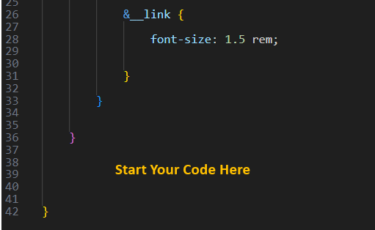

.about__bio {

font-size: 1.5rem;

}

# Project Page Responsive Design

Again, you will want to be inside of that same media code and then start writing your code right before the closing curly brace again.

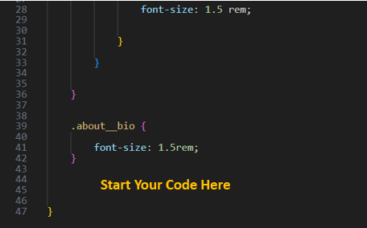

.projects {

&__bio-image {

height: 55vh;

}

&__items {

grid-template-columns: repeat(2, 1fr);

}

.text-secondary {

font-size: 3rem;

}

}

# Test Projects page

Save and see what we have for our projects page

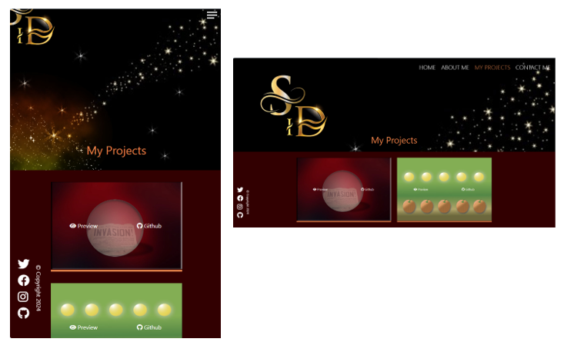

https://www.youtube.com/watch?v=_a5j7KoflTs

